Microprocessor System Lab7 Check List
- Date: 2024/11/11
- Please follow the instructions, and report to TAs after finishing check points.
- If you have any questions or troubles during the experiment, please feel free to ask TAs or the teacher, discussion with classmates is also encouraged.
- Please refer to the content from class slides, you can also use the resources from the internet.

Part I. Question
Please refer to the class content and answer the following questions.

1.1: Why 8051 need to read the value of IR sensor through an ADC?
1.2: How does the ADC transmit the result to 8051?

Part II. Example Projects
This lab is divided into 2 parts (IR sensor & Thermometer), please download the source codes on the google cloud and check the result after execution.

2.1: Please accomplish the circuit based on the wiring diagram 1. Connecting 8051, MCP3202 (ADC), GP2Y0A51SK0F (IR Sensor) and MAX7219 (7-segment display). Putting an object in front of the IR sensor in different distance and showing the voltage value (single digit for integer, 3 digits after decimal point). The LED will show the MSB 8 bits of the output voltage of the ADC’s variable resistance on the board.
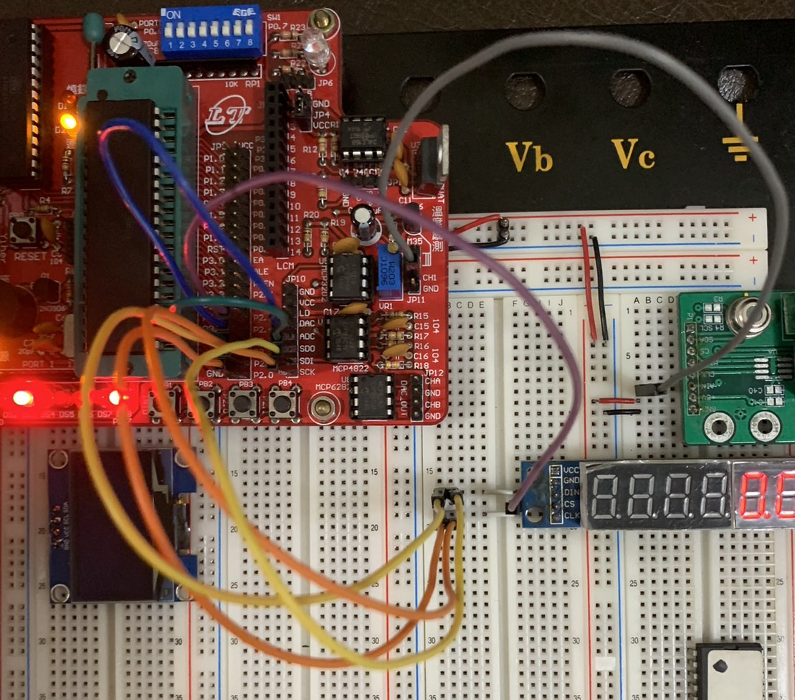
wiring diagram 1
2.2: Please follow the wiring diagram 2 to complete the circuit wiring. Connect the 8051, MLX90614(IR Thermometer) and OLED. The current ambient temperature and item temperature are displayed on the OLED. The item temperature is the temperature of the object close to the IR Thermometer. The item does not have to be touched with IR Thermometer.
wiring diagram 2
Part III. Practice
Please reference the sessions and source code of Example Projects. Try to design and implement the asking of Practice. (You can check the executed result from google cloud)

3.1 : The voltage output of the GP2Y0A51SK0F is roughly inversely proportional to the inverse of the distance. The excel figure below is the best fit linear relationship diagram made by TAs. Please convert the output voltage to distance according to this formula. Then write a firmware, display the distance (unit: cm) and voltage (unit: volts) detected by the IR Sensor on the seven-segment display respectively, each with four digits. The distance is from the tens digits to two decimal digits (xx.xx), and the voltage is from the single digits to three decimal digits(x.xxx).
(Hint. If the voltage is below 0.25V, let the distance be 99cm)
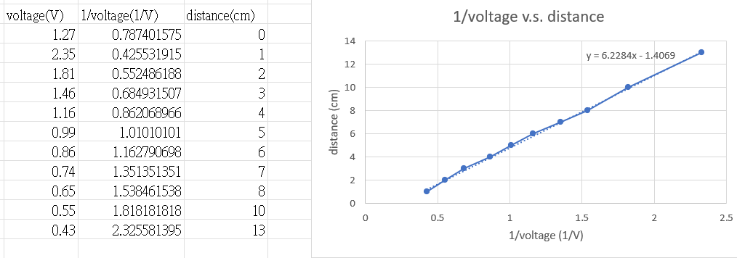
Distance = 6.2284 / voltage – 1.4069

